**Qualcomm’s new AR Smart Viewer is sleek and wireless**

**The company wants hardware makers to use its platforms to "unlock the metaverse"**

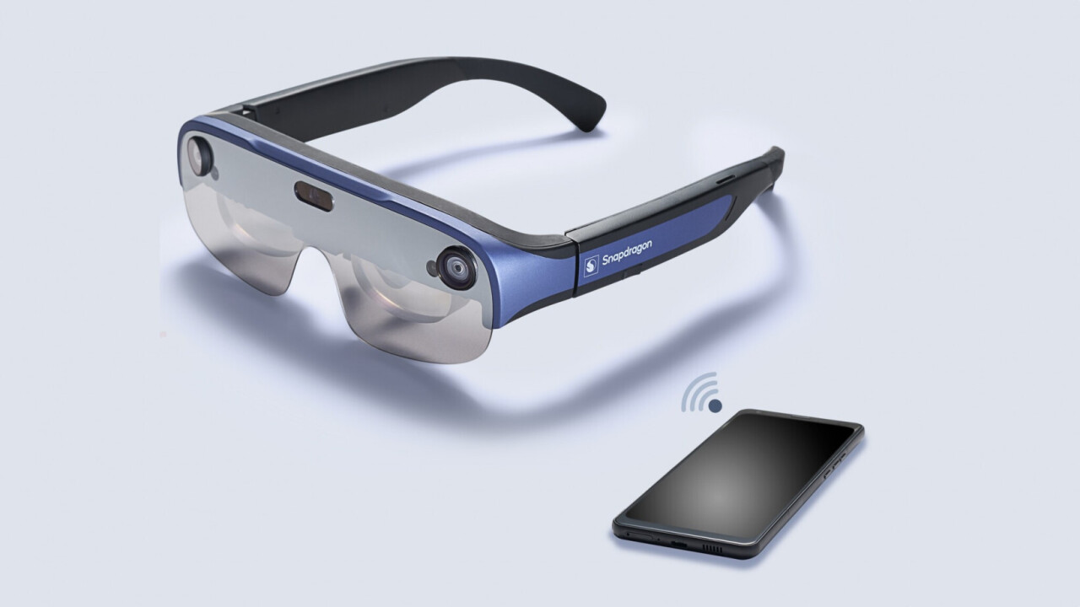

Qualcomm announced its XR1-based smart AR viewer last year before “metaverse” became propaganda.

Now, it is launching its new AR-XR2-enabled AR glasses so that computer hardware manufacturers can “enable a fully immersive metaverse unlocking experience.”

But if we look beyond marketing speech, the company's new headset has gone viral with a smooth design.

**What does the new headset offer?**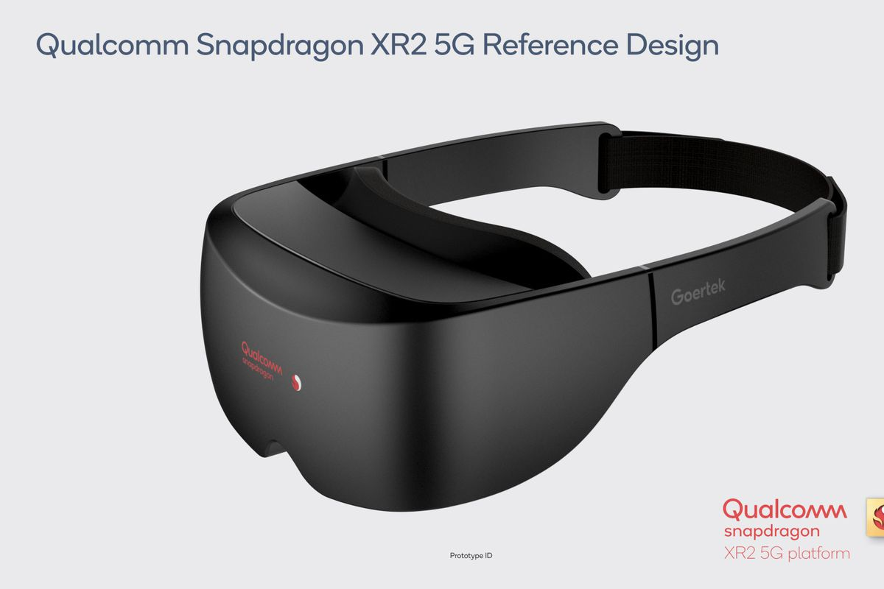

The company claims to have a 40% lower profile than the XR1 reference design, and has an equal distribution of weight to wear it comfortably longer. In addition, these mirrors - designed by Goertek - weigh only 115 grams.

The new specs of the sport are two 1920 x1080 displays - one on each eye - with a refresh rate of 90Hz. This can be helpful in displaying information in front of your eyes or in adding visual activity to work without any movement blurring.

To track your head and hands, it has two monochrome cameras - adding six degrees of tracking - and one RGB camera.

Some of these specifications and features are similar to the previous generation headsets. But one big difference here is that there is no need to attach it to a phone, PC, or processing puck.

The new smart AR monitor uses the Qualcomm FastConnect 6900 chip to be able to connect wirelessly between the headset and the phone or PC.

It is compatible with Wi-Fi 6 and 6E, so it can take advantage of 6GHz frequency and 160MHz channels on high connections and low latency connections. All of this allows for a large amount of data to be transferred between devices. In order to

enable self-sensing features such as streaming live video without interruptions to AR glasses.

The company also released the XR FastConnect Software Suite for developers to build applications. With this, it tries to reduce the delay between the camera shots and headsets that display the processed image based on your actions.

Qualcomm says that with this platform, it also allows low-power applications, so developers can design their own applications in such a way that tasks that require less resources do not produce battery power.

Qualcomm wants to empower the future of AR.

To date many companies, including Lenovo and Qualcomm have demonstrated AR-cable headsets. On the other hand, firms such as Oppo, NReal, and Snap have released wireless headsets.

Qualcomm believes that in the next few years, such headphones will spread across the market. And its predictions are not far off. We know that Google is working on translation-based AR glasses, with Meta reportedly releasing its first AR headset in 2024, and Apple recently showcased its XR device to its board members.

So we can expect a lot of action in this area. Qualcomm empowers many mobile operators to use their devices power, and can expect more hardware or "metaverse" companies to choose their AR platform for their products.

Qualcomm's smart wireless referee reference design is available from a few partners when it is launched, and more availability is coming in the next few months.